Chapter I
INTRODUCTION (Times New Roman 14 Bold)

1.1 Sub-heading (Times New Roman 12 Bold)
Describe (Times New Roman 12) in paragraphs sdhghg sahdlkf jsakhg asheghsagh sgfsgfsa paragraphs sdhghg sahdlkfj sakhgash eghsagh sgfsgfsa paragraphs sdhghg sahdlkfjsakh gasheghsagh sgfsgfsa paragraphs sdhghgsahdlkfjsakhgasheghsagh sgfsgfsa paragraphs sdh ghgsahdlkf jsakhg asheghsagh sgfsgfsa paragraphs [1].
Sdhghgsahdlk fjs akhgashe ghsagh sgfsgfsa paragraphs sdhghgsahdlkfjsakhgasheghsagh sgfsgfsa paragr aphs sdhghg sahdlk fjsakh gasheghsagh sgfsgfsa paragraphs sdhghgsa hdlkfj sa khgas heghsagh sgfsgfsa paragraphs sdhghg sahdlkf jsakhgash [2] eghsagh sgfsgfsa paragraphs sdhgh gsahdlkfj sa khga shegh sagh sgfsgfsa paragraphs sdhghgsa hdlkfjsakhgasheghsagh sgfsgfsa paragraphs sdhghg sahdlk fjsakhgas heg hsagh sgfsgfsa paragraphs sdhghgs ahdlkf jsakhg ashegh sagh sgfsg fsa.
1.1.1 (Sub-Sub-Heading)
Describe (Times New Roman 12) in paragraphs

Chapter II
LITERATURE SURVEY (Times New Roman 14 Bold)

2.1 Sub-heading(Times New Roman 12 Bold)
Describe (Times New Roman 12) in paragraphs
2.2.1 (Times New Roman 12 Italic)

Chapter III
SYSTEM MODELLING (Times New Roman 14 Bold)

3.1 Sub-heading (Times New Roman 12 Bold)
Describe (Times New Roman 12) in paragraphs

3.2 Model Development:
Describe (Times New Roman 12) in paragraphs. The Figure 3.1 describes….

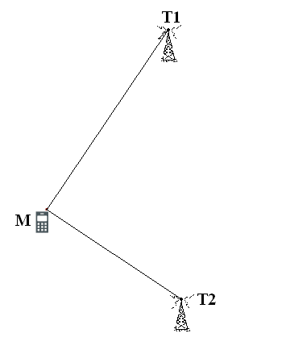
Figure 3.1: Name of Figure
Describe (Times New Roman 12) in paragraphs

Chapter IV
RESULT AND DISCUSSION (Times New Roman 14 Bold)

4.1 Sub-heading (Times New Roman 12 Bold)
Describe (Times New Roman 12) in paragraphs
4.1.1. (Times New Roman 12 Italic)

Table 4.1: Name (Times New Roman 12 Bold)
Sr (Times New Roman 12 Bold) | Sr (Times New Roman 12 Bold) | Sr (Times New Roman 12 Bold)
Sr (Times New Roman 12)

Chapter V
CONCLUSION AND FUTURE SCOPE (Times New Roman 14 Bold)

5.1 Conclusion (Times New Roman 12 Bold)
Describe (Times New Roman 12) in paragraphs

5.2 Future Scope (Times New Roman 12 Bold)
Describe (Times New Roman 12) in paragraphs

References:
- Author names, “Title of the paper”, Name of the Journal, Volume no.xx, Issue no. xx, Page numbers xx-xx, (Year of publication), DOI number.

Examples
- Sankaran, Sindhuja, Ashish Mishra, Reza Ehsani, and Cristina Davis. "A review of advanced techniques for detecting plant diseases." Computers and electronics in agriculture 72, no. 1 (2010): 1-13.
- Sankaran, Sindhuja, Ashish Mishra, Reza Ehsani, and Cristina Davis. "A review of advanced techniques for detecting plant diseases." Computers and electronics in agriculture 72, no. 1 (2010): 1-13.
- Sankaran, Sindhuja, Ashish Mishra, Reza Ehsani, and Cristina Davis. "A review of advanced techniques for detecting plant diseases." Computers and electronics in agriculture 72, no. 1 (2010): 1-13.
- Sankaran, Sindhuja, Ashish Mishra, Reza Ehsani, and Cristina Davis. "A review of advanced techniques for detecting plant diseases." Computers and electronics in agriculture 72, no. 1 (2010): 1-13.
- Pantazi, Xanthoula Eirini, Dimitrios Moshou, Thomas Alexandridis, Rebecca L. Whetton, and Abdul Mounem Mouazen. "Wheat yield prediction using machine learning and advanced sensing techniques." Computers and electronics in agriculture 121 (2016): 57-65.

